j0301480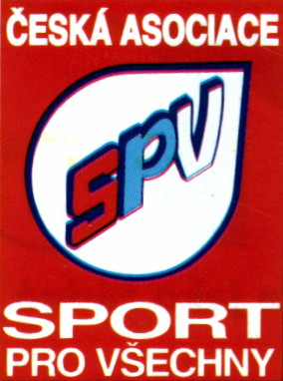**Krajská asociace SPV Vysočina**

|  |  |  |  |  |  |  |  |  |  |  |
| --- | --- | --- | --- | --- | --- | --- | --- | --- | --- | --- |
| **Družstvo** | |  | | |  | **R** | **P** | **Skóre** | Body | **Pořadí** |
| **1** | **2** | **3** | **V** |
| **1** | **ŠSK ZŠ Hrotovice** | https://img.obrazky.cz/?url=9f6d8249132f4065&size=3 | **3** | **3** | 2 | -- | -- | 4 : 0 | 6 | **1.** |
| 15:3; 15:10 | 15:2; 15:4 |
| **2** | **SK Valeč A** | **0** | https://img.obrazky.cz/?url=9f6d8249132f4065&size=3 | **3** | 1 | -- | 1 | 2 : 2 | 3 | **2.** |
| 3:15; 10:15 | 15:6; 15:7 |
| **3** | **SK Valeč B** | **0** | **0** | **https://img.obrazky.cz/?url=9f6d8249132f4065&size=3** | 0 | -- | 2 | 0 : 4 | 0 | **3.** |
| 2:15; 4:15 | 6:15; 7:15 |

Skupina: **mixy II.**